**PHASE 1: SUBMISSION CHECKLIST/SIGNOFF SHEET**

**GROUP#:** 1 **GROUP NAME:** YOUTHPROGRAM database

Deliverables:

* Description of the organization
* ER diagram with min/max specifications
* Constraints not in ER diagram
* Relational Schema

Assessment:

* Group Status Report
* Phase Summary (Discussion Thread)

We have each reviewed the contents of this deliverable.

Phase Leader Taylor Fischer __________________________

Phase Recorder Rachel Gordon __________________________

Phase Checker Kadin Suga __________________________

Technical Advisor David Sheleru __________________________

Technical Advisor Max Simmer __________________________

**1. Introduction**

The Centers for Social and Educational Development (CSED), a Midwest-based nonprofit, seeks to inspire people of all ages to reach their full potential through professional, leadership, cultural, and faith-based educational programs. As part of its mission, CSED supports a network of centers that offer youth programming, including series of ongoing classes as well as special events including workshops, service opportunities, and retreats. Mary Morgan, a staff member at CSED and expert user, has generously agreed to serve as a contact person and to provide input on the proposed database.

**2. Description of the Organization**

The Youth Program Database (YOUTHPROGRAM) stores information about the youth programs offered through CSED and participation at such events. The YOUTHPROGRAM Database contains data regarding the student attendees and their participation, the classes and events offered, and the staff and volunteers assisting with the various programs:

* Students that come to youth programs are included in the database. Each student has their student ID, first name, last name, phone number, birthday, email, and an emergency contact phone number stored in the database. Additional categories include a student’s level in school (e.g. high school or college), whether a student is involved in a leadership group, and whether a student’s parent(s) is an alum of CSED programs. Each student is mainly affiliated with one center, but a center can be affiliated with many students.
* Centers are physical branch locations within the CSED network that serve as hubs for classes. Each center has a name. Each center can host many different series of class sessions.
* A class session can only be hosted by one center. Each class session has an ID, a series level indicating the intended student audience, the date the session was held, and the topic presented. There is no maximum class size, and students can take multiple sessions (of the same series). Each session is taught by one or more staff members.
* Events are organized for students to attend, in categories such as workshops, service opportunities, and retreats. Each event is recorded with an event ID, name, date, location, event category, and intended student audience. Students can attend multiple special events, and there is not a set attendance capacity. Events are run by one or more permanent staff, often with the help of volunteers.
* Permanent staff can teach multiple class sessions or run multiple events. Each staff member is affiliated with one center, with no limit to the number of staff per center. Each permanent staff member is recorded with a unique ID, first name, last name, email, and phone number. Staff members must maintain satisfactory training, so training status and the date of training expiration are also recorded.
* Volunteers can help with special events. Each volunteer is recorded with an ID, first name, last name, email, and phone number. The training status and the next training expiration date are also recorded for volunteers.

**3. ER Diagram**

The figure below shows the ER diagram of the Youth Program Database (YOUTHPROGRAM).

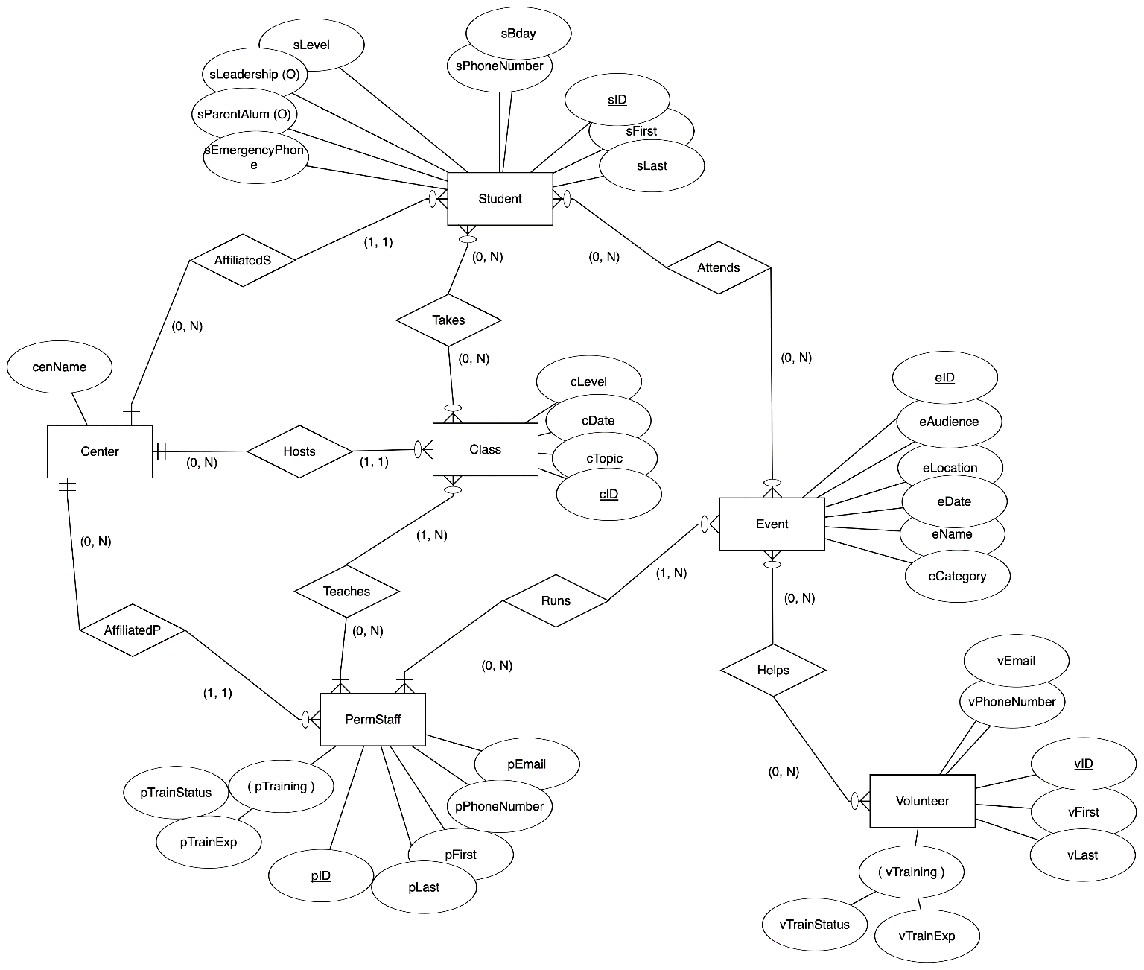

**4. ER Diagram Uncaptured Constraints**

The following is a list of constraints that are not captured by the ER diagram of YOUTHPROGRAM:

* Each event must have at least 2 adults running/present at the event. The minimum can be met with 2 permanent staff, or 1 permanent staff member and 1 volunteer.
* Students should only attend class sessions that match their student level.
* Student level in school (sLevel) can be either middle school, high school, college, grad, or other.
* Training status of permanent staff (pTrainStatus) and volunteers (vTrainStatus) can either be not started, initiated, good, flag, or failed.
* Event categories (eCategory) can be either workshop, service, retreat, or other.

**5. Relational Schema**

This section provides the relational schema with referential integrity and the relational table details.

**5.1 Relational Schema with Referential Integrity**

Student(sID, sFirst, sLast, sPhoneNumber, sBday, sLevel, sLeadership, sParentAlum, sEmergencyPhone, cenName)

foreign key (cenName) references Center (cenName)

Attends(sID,eID)

foreign key (sID) references Student (sID)

foreign key (eID) references Event (eID)

Class(cID, cLevel, cDate, cTopic, cenName)

foreign key (cenName) references Center(cenName)

Takes(cID,sID)

foreign key (cID) references Class(cID)

foreign key (sID) references Student(sID)

Teaches(cID, pID)

foreign key (cID) references Class(cID)

foreign key (pID) references PermStaff(pID)

Volunteer (vID, vFirst, vPhoneNumber, vEmail, vLast, vTrainStatus, vTrainExp)

Helps (vID, eID)

foreign key (vID) references Volunteer(vID)

foreign key (eID) references Event(eID)

Center(cenName)

Event (eID, eLocation, eName, eDate, eAudience, sCategory)

Center(cenName)

PermStaff(pID, pFirst, pEmail, pPhoneNumber, pTrainStatus, pTrainExp, pLast, cenName)

foreign key (cenName) references Center(cenName)

Runs(pID, eID)

foreign key (pID) references PermStaff(pID)

foreign key (eID) references Event(eID)

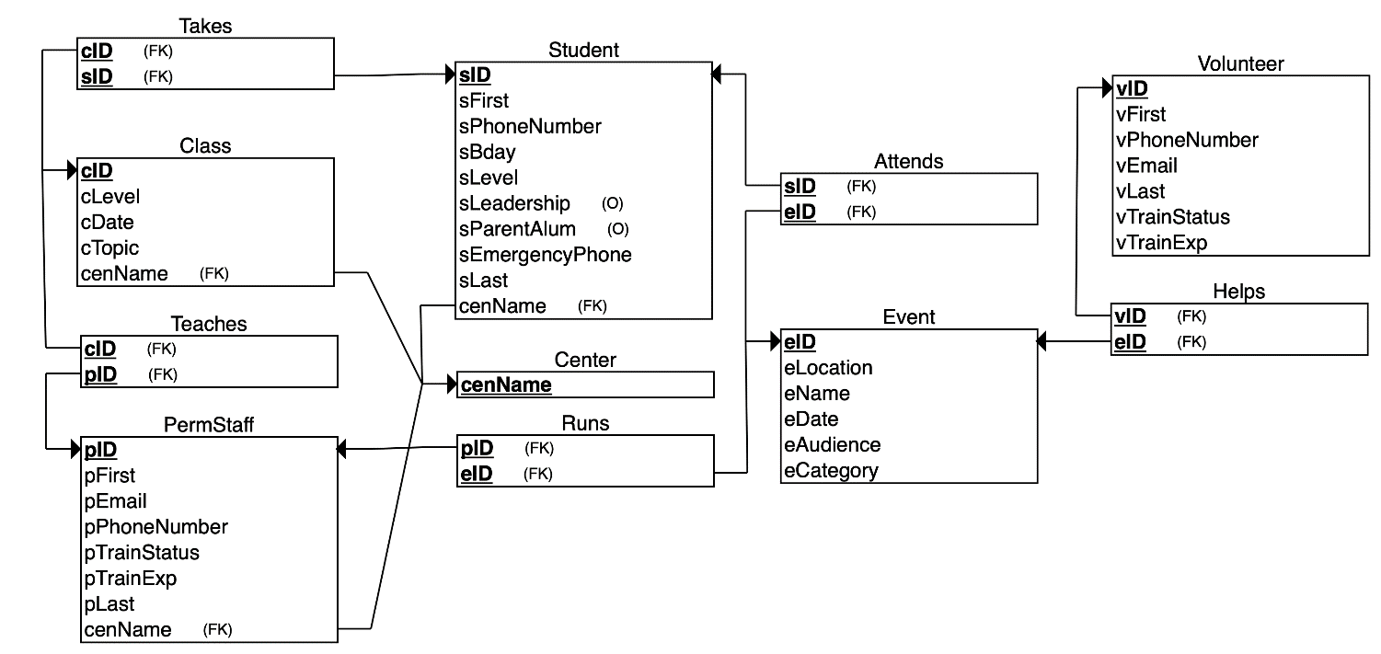

**5.2 Relational Table Details**

The relational schema given in Section 5.1 was mapped into the following tables in the YOUTHPROGRAM database. Primary keys have been underlined. Tables that have multiple attributes underlined represent composite keys.

|  |  |  |
| --- | --- | --- |
| **Table Name** | **Attribute** | **Description** |
| student | sID | Unique ID for identifying students |
| sFirst | Student first name |
| sLast | Student last name |
| sBday | Student birth date |
| sPhoneNumber | Student phone number |
| sLevel | Student’s level in school (ms, hs, col, grad, other) |
| sLeadership | Whether or not a student is involved in a leadership group |
| sParentAlum | Whether or not a student has a parent that is an alum of the organization |
| sEmergencyPhone | Emergency phone number for contacting a student’s guardian |
| cenName | Name of center student is affiliated with |
| permStaff | pID | Unique ID for identifying permanent staff members |
| pFirst | Permanent staff member first name |
| pLast | Permanent staff member last name |
| pEmail | Permanent staff member email address |
| pPhoneNumber | Permanent staff member phone number |
| pTrainStatus | Training status of permanent staff member (not started, initiated, good, flag, failed) |
| pTrainExp | Date when permanent staff member’s training expires |
| cenName | Name of center staff member is primarily affiliated with |
| class | cID | Unique ID for identifying a class session |
| cLevel | Class series name indicating the intended student level for the class |
| cDate | Dates the class is offered |
| cTopic | Topic covered in the class |
| cenName | Name of center that hosts the class |
| event | eID | Unique ID for identifying one-time special event |
| eName | Name of one-time special event |
| eDate | Date event was held |
| eAudience | Intended student audience for the event |
| eLocation | Location where the event was held |
| eCategory | Category the event falls under (workshop, service, retreat, other) |
| volunteer | vID | Unique ID for identifying volunteers |
| vFirst | Volunteer first name |
| vLast | Volunteer last name |
| vEmail | Volunteer email address |
| vPhoneNumber | Volunteer phone number |
| vTrainStatus | Training status of volunteer (not started, initiated, good, flag, failed) |
| vTrainExp | Date when volunteer’s training expires |
| center | cenName | Name of physical branch location where classes and some events are held and with which students and staff are affiliated |
| attends | sID | Unique ID for identifying students |
| eID | Unique ID for identifying one-time special event |
| takes | cID | Unique ID for identifying a class |
| sID | Unique ID for identifying students |
| teaches | cID | Unique ID for a class session |
| pID | Unique ID for permanent staff member teaching the course |
| runs | pID | Unique ID for permanent staff member running the event |
| eID | Unique ID for identifying one-time special event |
| helps | vID | Unique ID for identifying volunteers |
| eID | Unique ID for identifying one-time special event |

**GROUP STATUS REPORT**

**GROUP #:** 1 **GROUP NAME: YOUTHPROGRAM** **PHASE #:** 1

Dates & attendance at group meetings in this phase:

Tuesday, Sept 19 7:45 - 9:30 All group members present

* Selected dataset (friend of Taylor who works for a nonprofit)
* Assigned roles for this phase of the project
* Went over dataset details, potential entities for ER diagram and their attributes
* Started initial draft of ER diagram
* Assigned tasks and responsibilities for first part of the project (rough draft of ER diagram by Thursday 9/21)
* Scheduled two follow-up meetings for progress check-ins before the due date

Thursday, Sept 21 7:30 - 9:00 All group members present

* + Revised ER diagram
  + Decided on min-max pairs for entities
  + Created relational schema
  + Assigned remaining tasks to wrap up the project

Monday, Sept 25 7:30 - 8:00 All but Kadin

* + Reviewed final report for any last-minute changes and consistency

Overview of progress on project as of September 25:

The data requirements of the project have been collected. The deliverable includes a description of the requirements, an Entity-Relationship diagram with min/max pairs, a list of the constraints not captured by the ER diagram, and a Relational Schema.

CONTRIBUTIONS OF GROUP MEMBERS

Leader: Taylor Fischer

1. Obtained dataset information and attributes.
2. Spoke with Mary (expert contact for the database) regularly about the design of the database.
3. Went over ER diagram draft with Professor Silva.
4. Wrote introduction and description of organization.
5. Documented constraints not captured by ER diagram,
6. TABLE: student & center

Recorder: Rachel Gordon

1. Recorded notes during meetings and kept document updated with progress,
2. Filled out section 5.2 with relational table details based on initial information Taylor provided about the dataset.
3. Revised relational table details based on changes made to the diagrams.
4. TABLE: permStaff & teaches & runs

Phase Checker: Kadin Suga

1. Provided technology suggestions for software to create the diagrams.
2. Provided feedback on organization and optimization of database design.
3. Reviewed final report for consistency, accuracy, and error fixing.
4. TABLE: class & takes

Technical Advisor: Max Simmer

1. Created and revised ER diagram using erdplus.com.
2. TABLE: event and attend

Technical Advisor: David Sheleru

1. Created relational schema diagram and outline.
2. TABLE: volunteer & helps